**1.**

**ID/Name:** 01_SignUpInvalid_July27_22

**Description:** User can create account with invalid email which follows proper format, without

experiencing any error.

**Environment:** Test performed on 64bit Windows 10 Enterprise, Google chrome v103.0.5060.134

64-bit, Screen resolution 1920x1080p, Bandwidth 50Mbps Up/Down.

**Source URL:** <https://www.pggoodeveryday.com/signup/tide-coupons>

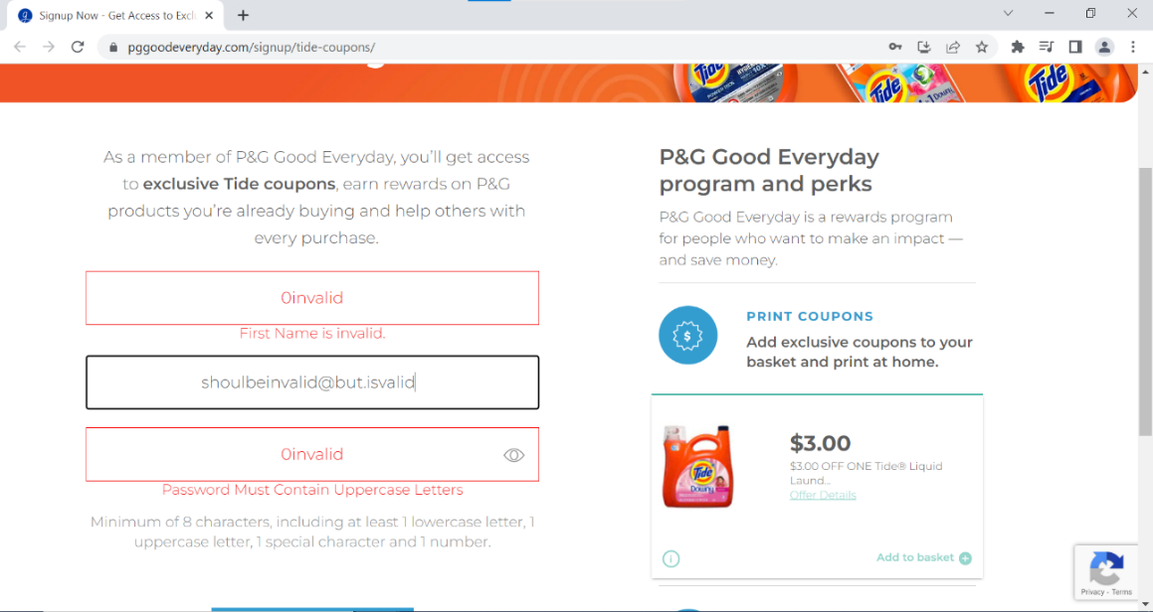**Visual Proof:**

**Steps to Reproduce:**

1. Navigate to URL <https://tide.com/en-us>.
2. Click Register.
3. Click Sign up now.
4. Enter invalid first name, email, and password.
5. Email is the only field not showing error after getting invalid data.

**Expected vs. actual results:** After entering the wrong first name, email, and password the Create

Account button shouldn’t be able to be clicked. But after entering valid first name and password, and invalid email, the Create Account Button could be pressed.

**Reported by and Date:** Tanmay Sharma, SDET team [27/07/22]

**Priority:** P2